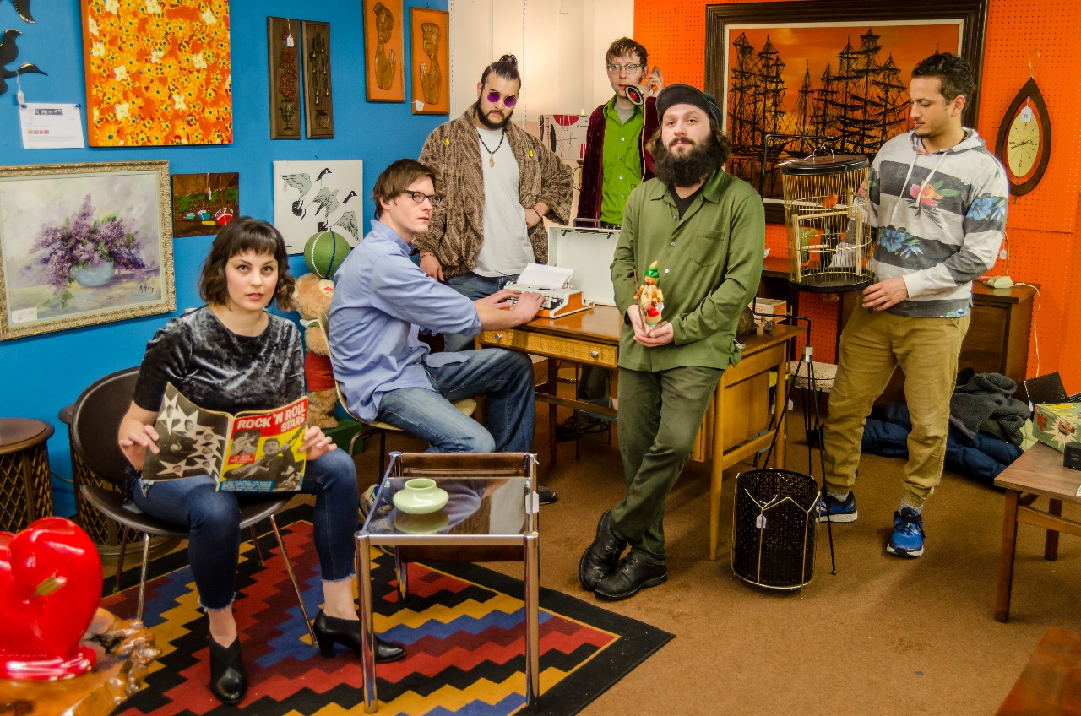

OCELOT WIZARD
  - AltErnative Rock
  - from Missoula, Montana

  - __________________________________________________

  - PRESS KIT
  - for booking consideration
Online

Website: www.ocelotwizardmusic.com
Email: ocelotwizardmusic@gmail.com

Facebook: www.facebook.com/ocelotwizard
Youtube: https://www.youtube.com/channel/UCqEur705NNPu3u6wpHkiDow
Instagram: www.instagram.com/ocelotwizardmusic

Band Contacts

Manager: Will Peterson 952-457-8548
Booking: Aaron Williams 406-465-3665
Marketing/PR: Amelia Thornton 406-250-5616

Label: Self-Released
Hometown: Missoula, Montana, USA
Genre: Alternative Rock
Influences: Dave Matthews Band, Paul Simon, Herbie Hancock, Fleet Foxes, Jean-Luc Ponty
Sounds Like: Dave Matthews Band, Paul Simon, Lord Huron, The National

Short Description of Style:
Ocelot Wizard’s groove is a concoction of rock riffs, jazzy improvised solos, and funk/hip-hop rhythms. They've got Keys, Drums, Bass and Electric Guitars with shred pedals, Electric Violin, and haunting reverb-infused Vocals. Ocelot Wizard's singer-songwriter lyricism and retro instrumental vibes have been known to emotionally and physically move audiences of all ages.

Technical Rider
OCELOT WIZARD is thrilled that you booked us! Below is a list of our technical requirements, to ensure a quick and efficient setup and happiness for performers and venue alike. If there are any questions or if you have trouble providing any of the below mentioned please get in touch with us before the day of the show and we will be happy to find a solution.
The Musicians:
Will Peterson: Lead Vocals (mic), Lead Acoustic-Electric Guitar (line-in)
Jesse Williams: Lead/Backup Vocals (mic)
Josh Chai: Drum Kit/Backup Vocals (to be mic ‘d)
Kia Adibzadeh: Keyboard (line-in or mic amplifier)
Sean Burress: Electric Guitar and Bass (line-in with pedalboards)
Amelia Thornton: Electric Violin/Viola (can DI through Roland amplifier) and Backup Vocals (mic)

See the Stage Plot for all details on amps, line-in, etc.

Sound & Lighting:
Our sound is characterized by an atmospheric slight reverb, the use of effects from pedalboards on our guitars and bass, reverb/chorus/delay directly from violin amp, clean keyboard sound, and rock drum attack sounds. Some reverb and compression on the vocals is good, but please make sure that lead vocals are crisp and do not get drowned out by instruments. We love Will’s poetry to be understandable.
Ideally the venue will provide a large PA system for the show with sufficient power to supply undistorted and feedback proof monitor system. The OCELOT WIZARD musicians/singers perform at their best when they have their own monitors with separate mixes. For very large venues we also would need 2 side fills.
Staff:
For bars and larger venues, we will need a qualified sound engineer. Lighting is left to the discretion of the onsite lighting designer, but please maintain visible levels of light on stage, although colors changes are great!
For small breweries and venues, we can provide our own sound and setup.

Equipment sharing & Sound check:
The drummer always plays his own drum set and will not share his drums with other bands.
All other musicians will not share their instruments or gear with opening or following bands.
We will need at least a 30 min sound check; 60 minutes including setup is ideal.
Arrival:
Please provide detailed directions in English two weeks before the day of the show with the complete address of the venue and a telephone and email contact. We need a safe and free parking space available for our vehicles close to the venue and details for the unloading/loading zone. Please provide arrival, sound check, doors open and on-stage times. The promoter or sound engineer should be at the venue at OCELOT WIZARD’s arrival time.
Food & Drinks:
• Six (6) hot and healthy meals, NO Fast food, please!
(1 gluten free meal for Kia)
• Green Room Snacks: cheese & salami & crackers platter or fruit/veggie platter or similar
• Coffee & herbal tea and honey, Ginger Ale, local beer or wine
• 12 bottles of cooled non-carbonated water for stage and backstage.
Back Stage:
Small venues: lockable/security monitored Green Room with seats and table for keeping personal items, gear bags, etc. and for relaxing in before/after show.
Large venues: clean dressing rooms with toilet, sink, showers and mirrors for the band.
Accommodation:
3 (non-smoking) hotel rooms with two beds per room, or clean and quiet (non- smoking) accommodation for 6 people with beds, bathrooms and showers. A safe parking space near the accommodation should be available.
Merchandise:
A table with 2 chairs in a lit area for our merchandise. Preferably in the same room as the show. We will provide our own personnel for the Merch Table.

Guest List:
Ocelot Wizard would like to have up to 12 names on the guest list for free entry to the show.
Advertising and Promotion:
Please contact: Amelia Thornton at 406-250-5616 or email: artworkstrings@gmail.com.
Or visit www.ocelotwizardmusic.com for more information.
Management:
Please contact: Will Peterson at 952-457-8548 or email: ocelotwizardmusic@gmail.com.

Thank you for all of your help and we are so excited to bring our heartfelt, loving, and rocking music to your venue!

